Date______________ Name_____________________ Job ______________________
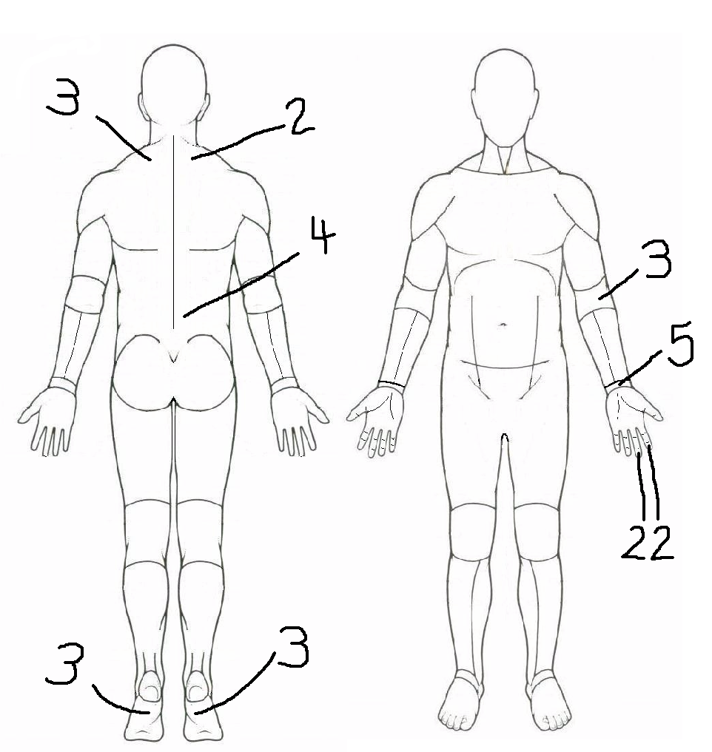
- In the last month, have you experienced discomfort that was
made worse by working?
Use the pictures below and rate your pain or discomfort
from 1 (very weak discomfort) to 5 (very strong discomfort).

1 |  | 2 |  | 3 |  | 4 |  | 5
Very Weak |  | Weak |  | Medium |  | Strong |  | Very Strong

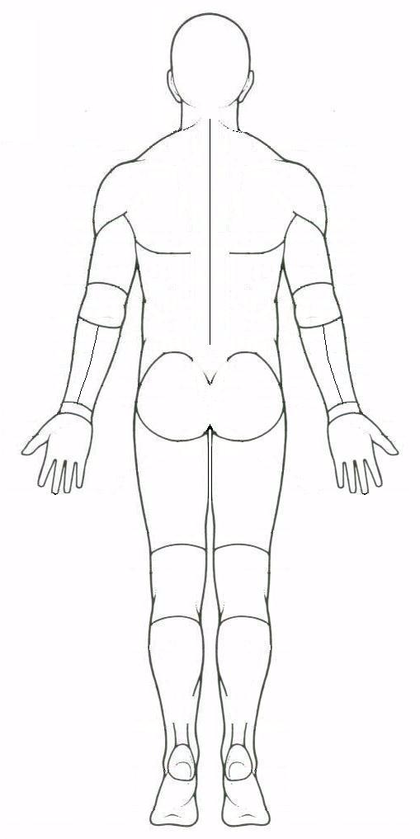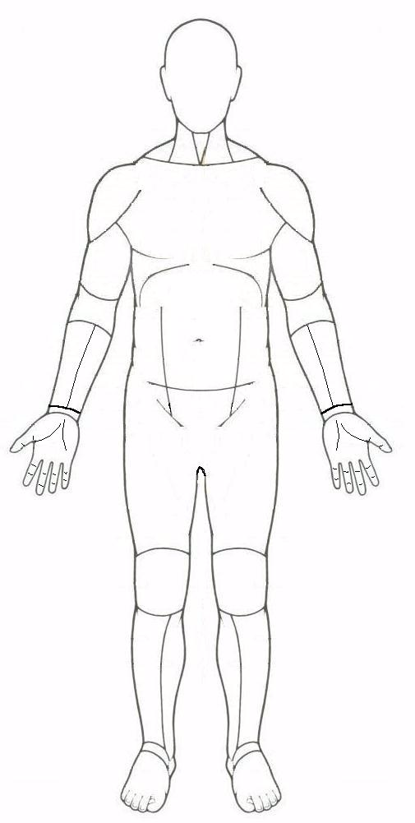
Left Right Right Left
- What things at work do you believe make your discomfort worse?

