Date: | Location:
Assessors (list): | Employees observed (list):
Job or Task (describe):
MSI Hazards Observed | Present? |  | Repetitive? | Sustained? | When and why risk factor occurs (task, workstation, load, etc.) | Describe risk factor  (magnitude, direction, duration) | Controls to eliminate or minimize risk factor
Force |  |  |  |  | *task; object; forward reach; below knee; above chest; distance moved; twisting | *typical & highest load; how many; hours | *mechanical assists; working height; training; etc.
Lift, Lower
Push, Pull
Carry
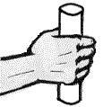
Power Grip
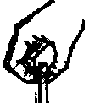
Pinch Grip
Awkward Postures (bending or twisting) |  |  |  |  | *task; reason for posture; forceful; rapid? | *bend, twist, forward, sideways; angle; hours | *adjustable height; reaching tool; etc.
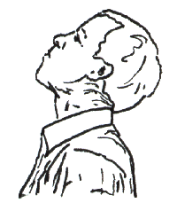
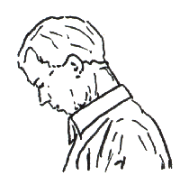
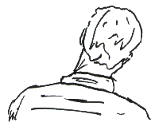
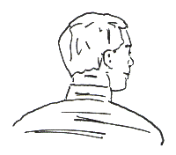
Neck
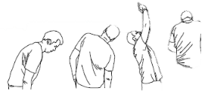
Back
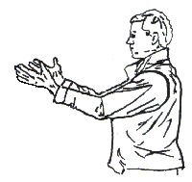  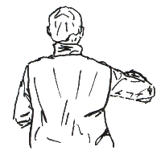  Shoulder | L | R
Elbow | L | R
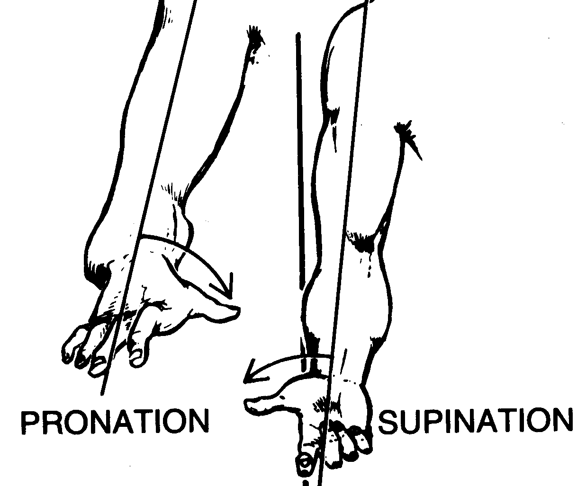  Forearm | L | R
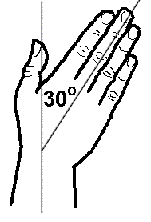  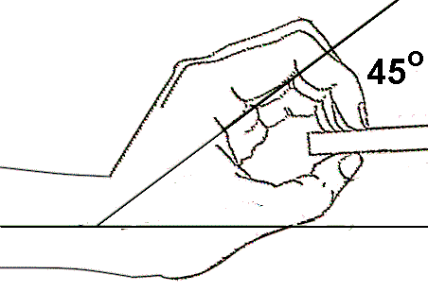  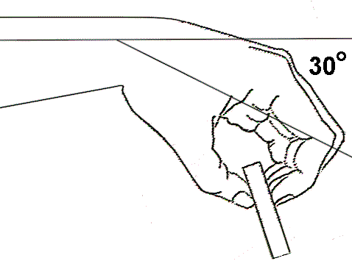  Wrist | L | R
Hip | L | R
Knee | L | R
Contact Stress |  |  |  |  | *task; body part; reason for contact stress | *duration, load | *gloves; padding; etc.
Leaning on edges, pressure on handles, hammer with body
Other Contributing MSI Risk Factors |  |  | *task; description and reason for risk factor |  |  | *magnitude; duration | *clothing; PPE; task rotation; rest breaks; etc.
Vibration (hands, whole-body)
Workplace layout (flooring, reaches, heights, seating)
Characteristics of objects handled (size, shape, condition, weight distribution, handles)
Environment (hot/cold; lighting)
Organization of work (work-recovery cycles, task variability, work rate)
Other

List all controls implemented or planned to address identified MSI Hazards, along with person(s) responsible for implementation, date initiated, date completed (control implemented), and the impact of controls on eliminating or minimizing MSI hazards. Indicate interim and permanent controls.
Control  (describe all interim or permanent controls that arise from the current inspection) | Person(s) Responsible | Date Initiated | Date Completed | MSI Hazard Re-evaluation (Impact of Controls)

When the MSI Hazard Identification, Assessment and Control Plan were developed at a different, representative location, each site must verify that:
- The hazard identification and risk assessment accurately represent the work performed and MSI risk at this location.
- There are no unique aspects of work (job, task, environment, store design, workstation design, equipment, etc.) at this location that were not considered in the representative hazard identification and control plan.
- The control plan can be implemented effectively at this location without modification.
Verification of Representative MSI Hazard Identification, Assessment and Control Plan
Date: | Location:
Employees Verifying Representative MSI Hazard ID and Controls: | Assessor modifying MSI Hazard ID, Assessment and Controls:
Unique Aspects of Work, Environment, Workstation, or Equipment at this Location (Different than Representative Location):
Modifications to Hazard Identification and Risk Assessment:
Modifications to Control Plan for this Location:

