COVID-19 OPERATIONAL PLAN FOR WORKPLACES
To ensure workplaces have documented their risk assessment and risk mitigation measures consistent with Public Health guidance and the Occupational Health and Safety Act and regulations, all employers must develop a written COVID-19 Operational Plan.

You must comply with the following provisions of the Mandatory Order:
- Owners and managers of every workplace must take every reasonable step to ensure minimal interaction of people within two metres of each other, except in compliance with guidelines issued by WorkSafeNB and the Chief Medical Officer of Health. | - All owners and managers of every workplace must take every reasonable step required to prevent persons who exhibit symptoms of COVID-19 from entering the workplace, in accordance with advice issued by the Chief Medical Officer of Health or WorkSafeNB. | - All owners and managers of every workplace must take every reasonable step required to prevent persons from entering workplaces who have travelled outside New Brunswick in the previous 14 days.

You do not need to submit the operational plan to WorkSafeNB before reopening. Individual COVID-19 operational plans will not be reviewed or approved by WorkSafeNB or Public Health. However, plans will need to be produced during inspections or if a complaint is made and an investigation follows by one of the regulatory bodies.

The following template may serve as a starting point for your COVID-19 Operational Plan. It helps guide you through some of the key areas to consider when assessing the risk surrounding the safe opening and continued operations of your workplace. Additional guidance from an industry association may also be available to help you address industry- or workplace-specific needs. If you operate across various provinces, requirements specific to New Brunswick must be included in your plan.

Just as viruses can mutate, guidelines related to COVID-19 can change. As an employer, you’re responsible for keeping up to date on current guidelines and to change your plans as required. Refer to New Brunswick Public Health and WorkSafeNB websites for updates that may affect your workplace.
This template is available in a Word format.

COVID-19 OPERATIONAL PLAN FOR WORKPLACES – TEMPLATE
Company Name: _____________________________________________________________________
Plan Owner: ________________________________________________________________________
Plan Implementation Date: ________________________
Plan Revision Date: _____________________________
Plan has been reviewed to assess any new risks or changes to regulatory guidelines (suggest monthly review):
___
Name Date Name Date

Name Date Name Date

Name Date Name Date

Effective Risk Mitigation – Infection and Prevention Controls
The best prevention controls in a workplace are achieved by first focusing on physical distancing and taking every reasonable step to restructure physical settings to increase space between people. Once you have exhausted all reasonable options in this category, move to the next stage within the inverse pyramid and conduct the same exercise, and so on until you reach PPE as a final step, if required.
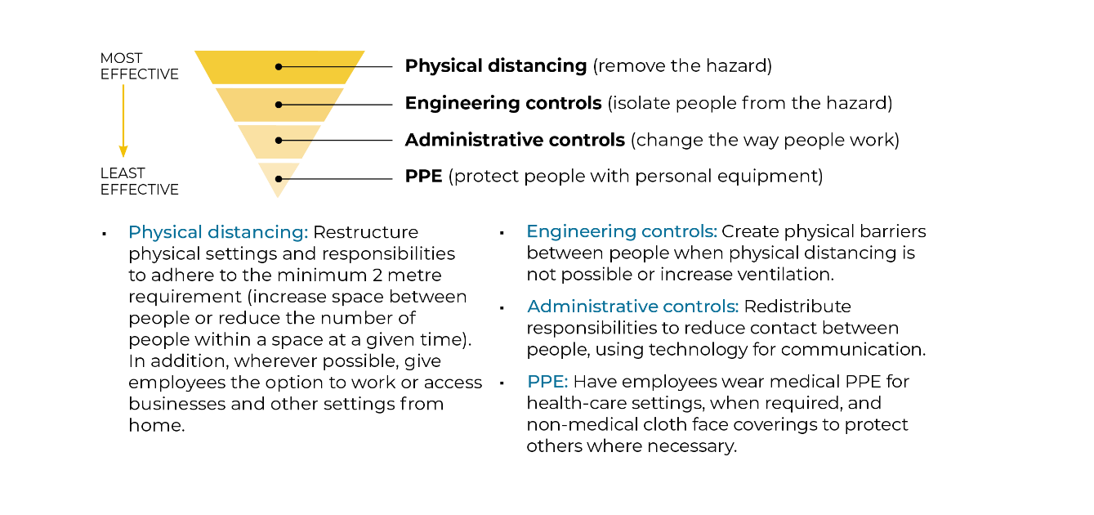

Action Items | Resources  (Examples, Templates, Guidance Documents) | Details of Implementation  (PPE Specifics, Frequency, Policy Name, Process, etc.) |  | How is it communicated?  (Poster, Training, Verbal Notice) | Status  (Done, In Progress, Not Started, N/A)
Public Health Requirements (applies to EVERY workplace)
Risk Assessment | Risk Assessment Guideline Health Canada
Complete a risk assessment to determine the engineering, administrative controls and/or PPE
controls necessary to mitigate the risk of COVID-19 exposure.
Determine whether you need isolation elements as part of the operational plan for your workplace. For requirements, see page 14 of the Embracing the New Normal guide.
Physical Distancing
Implement a two-metre physical distance protocol. | Physical Distancing
- Consider both employees and visitors/customers.
- Arrange furniture to promote the two-metre rule.
- Provide visual cues (ensure two-metre markings on floor, directional movement for
patrons, no-stopping areas in narrow hallways, etc.).
- Determine if installation of physical barriers such as partitions or Plexiglas is feasible.
Establish a protocol to ensure people don’t congregate in groups (stagger start and break times, virtual rather than in-person meetings, limit access to common areas, etc.). | WorkSafeNB FAQ
Evaluate options to reduce staff onsite, such as having some staff work from home, changing shift times and, implementing flexible work hours.
Evaluate the risk of employees coming closer than two metres in all parts of the facility. Stairwells, entry and exit points and narrow hallways can present a challenge. Consider implementing one-way traffic zones where possible (one stairwell for walking up, a different one for walking down).
Hand and Respiratory Hygiene
Promote frequent handwashing. | Handwashing Poster
Have handwash stations readily available and equipped with running hot/cold water and adequate soap and paper towel.
Have minimum 60% alcohol-based hand sanitizer readily available. | Hand Sanitizer Poster
Communicate frequently about good respiratory hygiene/cough etiquette. | Protect yourself and others
Evaluate the workplace for shared objects and common areas and increase frequency of cleaning of touched surfaces/objects (minimum twice daily). | Cleaning and Disinfection for COVID-19

Action Items | Resources  (Examples, Templates, Guidance Documents) | Details of Implementation  (PPE Specifics, Frequency, Policy Name, Process, etc.) |  | How is it communicated?  (Poster, Training, Verbal Notice) | Status  (Done, In Progress, Not Started, N/A)
Public Health Requirements (applies to EVERY workplace)

Screening and Monitoring
Determine if your workplace must implement a passive or active screening process. For more information on active screening, see page 11 of the Embracing the New Normal guide. | Screening tool
Prepare for the possibility that an employee tests positive for COVID-19 and may have been in the workplace. Inform your employees of the procedures to be followed. | WorkSafeNB FAQ

Receiving payment for good and services
- Use electronic payment devices (if possible). We encourage you to use the tap option or clean devices after each use.
- If you must handle money, ensure regular handwashing and have
minimum 60% alcohol-based hand sanitizer readily available.
Cleaning and Disinfection | Cleaning and Disinfection for COVID-19
Ensure availability of all necessary supplies for cleaning and disinfecting.
Washrooms
- Equip with hot and cold running water under pressure, liquid soap, paper towel, toilet paper and garbage containers where possible.
- Hand-washing posters must be posted. | Handwashing Poster
If multiple stalls and sinks are provided in washrooms, consider whether you need to limit
access through maximum numbers allowed in the space at one time.
Additional Considerations:
Use non-medical face coverings for employees, clients and visitors to minimize the risk of transmitting COVID-19.  Develop procedures for selection, use, decontamination (if applicable), storage, handling, limitations, inspection requirements, change-out requirements and employee training, if coverings are used. | Health Canada information on  non-medical masks and face coverings
Consider implementing a self-isolation unit. Isolate persons showing signs of COVID-19 immediately at the workplace. Keep the person isolated until they are picked up to avoid contaminating others.
Provide mental health support to all workers, including access to an employee assistance program (EAP) or information on public health supports, if available. | GNB Mental Health Resource
Action Items | Resources  (Examples, Templates, Guidance Documents) | Details of Implementation  (PPE Specifics, Frequency, Policy Name, Process, etc.) |  | How is it communicated?  (Poster, Training, Verbal Notice) | Status  (Done, In Progress, Not Started, N/A)
Public Health Requirements (applies to EVERY workplace)
If your workplace CANNOT ensure minimal interaction of people within two metres of each other – the requirements listed below must be implemented
Where feasible, install physical barriers (clear plastic guard, cubicle walls of appropriate design, curtains).
If physical barriers are not possible:
- Implement active screening processes.
- Implement enhanced handwashing and sanitation/cleaning practices in shared areas and for shared items. | Cleaning and Disinfection for COVID-19
Provide personal protective equipment such as: | OHS Guide-PPE
- Hand protection (nitrile, rubber or latex gloves)
- Eye protection (safety glasses, goggles or face shield)
- Other PPE as determined necessary through the risk assessment
In areas/rooms where minimal interaction of people within two metres of each other is not possible, maintain a visitor and employee logs. This must be made available to Public Health for contact tracing purposes if it’s identified that a person who tested positive for COVID-19 was present in that area.
Additional Protection
Use non-medical face coverings for employees, clients and visitors to minimize the risk of transmitting COVID-19.  Develop procedure for selection, use, decontamination (if applicable), storage, handling, limitations, inspection requirements, change-out requirements and employee training, if face coverings are used. | Health Canada information on  non-medical masks and face coverings

Action Items | Resources  (Examples, Templates, Guidance Documents) | Details of Implementation  (PPE Specifics, Frequency, Policy Name, Process, etc.) |  | How is it communicated?  (Poster, Training, Verbal Notice) | Status  (Done, In Progress, Not Started, N/A)
Occupational Health and Safety Act and Regulation Requirements
Communicate to employees and supervisors their responsibilities under the OHS Act and regulations. | OHS Guide-Three Rights
Communicate to all employees their three rights under the OHS Act. | Guide to Legislation - Three Rights
Provide employee orientation, information and training on the new policies and processes implemented regarding COVID-19. | OHS Guide-New Employee Orientation
Provide employee training on the work refusal process. | Right to Refuse
Keep records of visitor and employee log (with confirmation those individuals were actually screened), as well as orientation, training and inspections.
Ensure supervisors are knowledgeable of guidelines and processes established by Public Health.
Ensure all employees receive information, instruction and training on the personal protective equipment required to protect against COVID-19.
Provide, maintain and make available personal protective equipment.
Implement a disciplinary process for correction of employee violations of company policies and procedures.
Consult on any new policies and processes established in relation to COVID-19 (JHSC or health and safety representative, if any, or employees). | OHS Guide-JHSC
Provide competent and sufficient supervision to ensure employees are complying with policies, procedures and processes established. | OHS Guide topic-Supervision
Communicate to all staff the requirement to co-operate with Public Health if there is a suspected or confirmed case of COVID-19 in the workplace. Public Health will advise the employee and/or the employer if there is a need to communicate with the employer or workforce during contact tracing. If the employer is advised of a positive case, they must then report it to WorkSafeNB. | WorkSafeNB FAQ
Include guidance that is not provided in this template and is recommended by your industry association or other resources.
Sector Specific Additional Resources

